**EXPERIMENT-6**

**VACCUM CLEANER**

**AIM:**

To write and execute the python program for vaccum cleaner.

**ALGORITHM:**

1. **Environment Representation:**
   * Define a data structure to represent the environment in which the vacuum cleaner operates. The environment can be a grid or a set of locations with dirt and the vacuum cleaner's current position.
2. **Define Vacuum Cleaner Actions:**
   * Identify and define the possible actions that the vacuum cleaner can perform in the environment. Common actions include moving left or right and cleaning the current location.
3. **Implement Simple Reflex Agent:**
   * Design a simple reflex agent that makes decisions based on the current percept (sensory input). For example, the agent could move to the left if there's dirt on the left, move to the right if there's dirt on the right, and clean the current location if it's dirty.
4. **Define Environment Dynamics:**
   * Implement the dynamics of the environment, including the generation of dirt and the vacuum cleaner's movement. Define the conditions under which dirt appears and how the vacuum cleaner's position changes.
5. **Simulate the Environment:**
   * Run a simulation of the environment, allowing the vacuum cleaner to make decisions based on its percept and perform actions accordingly. Print or visualize the state of the environment at each step, including the location of dirt and the vacuum cleaner's position.

**CODING:**

import random

def display(room):

print(room)

room = [

[1, 1, 1, 1],

[1, 1, 1, 1],

[1, 1, 1, 1],

[1, 1, 1, 1],

]

print("All the rooom are dirty")

display(room)

x =0

y= 0

while x < 4:

while y < 4:

room[x][y] = random.choice([0,1])

y+=1

x+=1

y=0

print("Before cleaning the room I detect all of these random dirts")

display(room)

x =0

y= 0

z=0

while x < 4:

while y < 4:

if room[x][y] == 1:

print("Vaccum in this location now,",x, y)

room[x][y] = 0

print("cleaned", x, y)

z+=1

y+=1

x+=1

y=0

pro= (100-((z/16)*100))

print("Room is clean now, Thanks for using : 3710933")

display(room)

print('performance=',pro,'%')

**OUTPUT:**

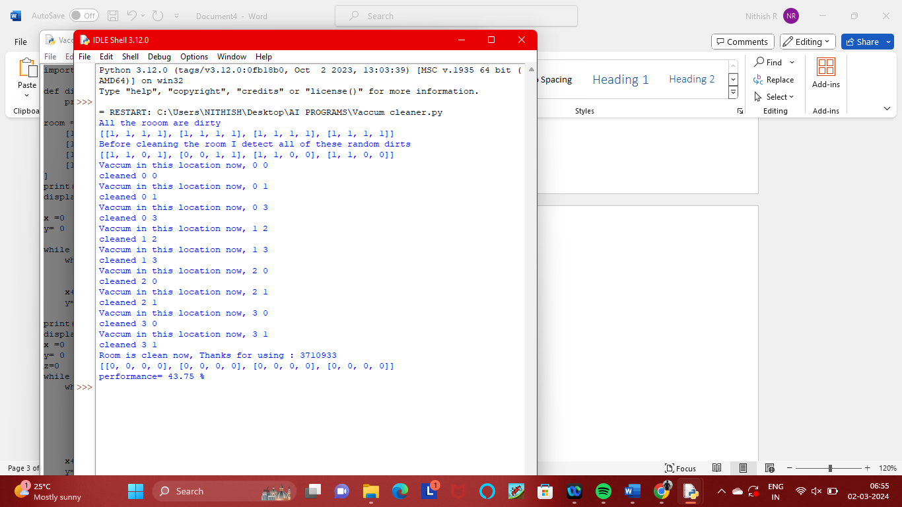

**RESULT:**

Thus the result has been successfully executed and verified.